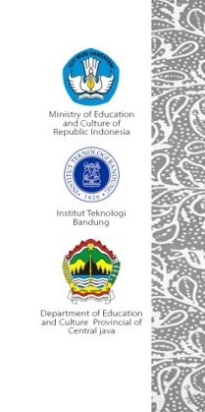
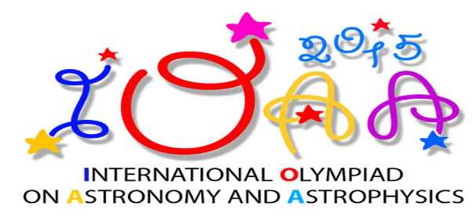

- During observation test using small telescope, you will receive :
- Problem sheet
- Answer sheet
- Additional sheet
- Flashlight

- During naked eye test, you will receive :
- Problem sheet
- Answer sheet
- Additional sheet
- Flashlight

- During observation test using main telescope, you will receive :
- Problem sheet
- Answer sheet
- Additional sheet
- Headlamp
- Clip Board

- During observation test using planetarium (in case of rainy or cloudy), you will receive :
- Problem sheet
- Answer sheet
- Additional sheet
- Flashlight
- Clip Board

- Please write your student ID in every answer sheet :

- The total duration for naked eye + small telescope observation is 60 minutes, main telescope 20 minutes, planetarium 15 minutes

